Version 1.2

Revision History

|  |  |  |  |
| --- | --- | --- | --- |
| **Date** | **Version** | **Description** | **Author** |
| 25.10.2015 | 1.0 | Basic Information | Felix Morsbach |
| 29.10.2015 | 1.1 | Revision | André Helbig |
| 01.11.2015 | 1.2 | Cucumber | André Helbig |
|  |  |  |  |

Table of Contents

1. Use-Case Name 4

1.1 Brief Description 4

2. Flow of Events 4

2.1 Basic Flow 4

2.2 Alternative Flows 5

2.2.1 Data is not valid 5

3. Special Requirements 5

4. Preconditions 5

4.1 App started 5

4.2 Internet Connection 5

5. Postconditions 5

5.1 Redirected to login screen 5

6. Extension Points 5

# Use-Case Name

## Brief Description

This Use-Case will provide the possibility to create a new account for an unregistered user.

# Flow of Events

## Basic Flow

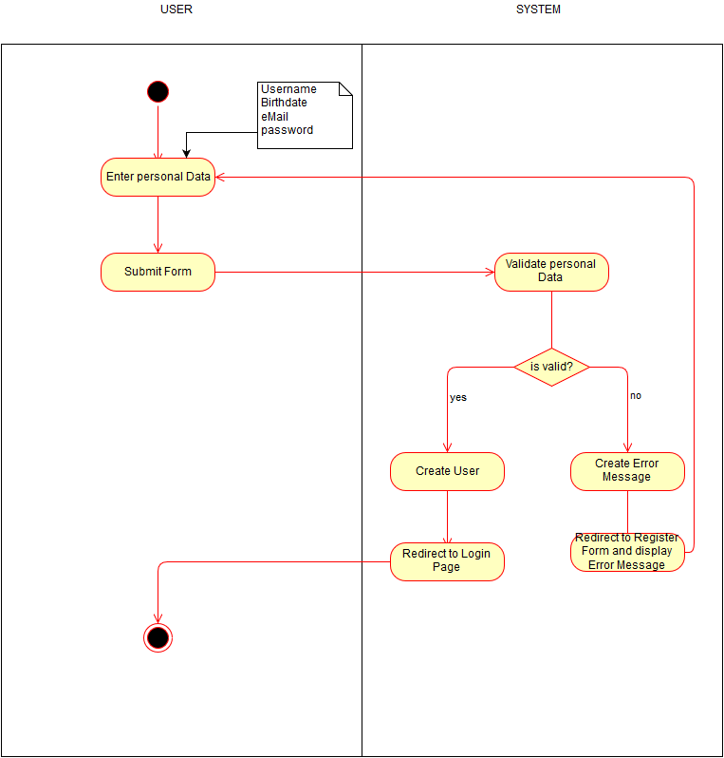

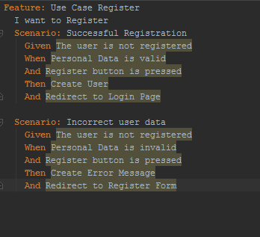

## Alternative Flows

### Data is not valid

If the personal Data which the user send to the System are not valid, an error message will be created and send to the user. This error message will provide Information on the problem which occurred, if possible.

#### User account already exist

If the entered Data is not valid because there is already a registered user with e.g. this Username, the system will notice this, and may ask the user to think of an alternative username, or ask him if he/she lost the password.

# Special Requirements

n/a

# Preconditions

## App started

The app must be running.

## Internet Connection

To successful register a new account, an internet connection is necessary.

# Postconditions

## Redirected to login screen

After a successful registration, the user will be directed to the login screen.

# Extension Points

n/a